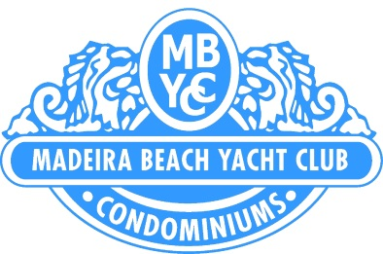

Board of Directors Meeting

June 1, 2016

10:00 a.m.

Clubhouse
210 Medallion Blvd., Madeira Beach, FL 33708

Call to Order
Establishment of Quorum
Proof of Notice
Approval of Minutes of Prior Meetings
May 11, 2016
Open Forum – addressing agenda items only

Manager’s Report

Paint project update only

Old Business:

Approval to transfer funds from reserves to pay for pool furniture re-strapping

New Business :

Approval to transfer funds from reserves to operating for the paint project Phase I

Approval to transfer funds from reserves to operating for pool acid washing and re-marcite of small pool.

Review and approval of 2016/17 insurance policies.

Adjournment:

Posted May 27, 2016

