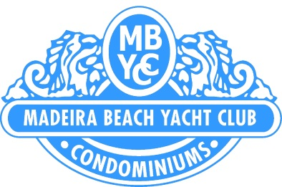

Board of Directors Meeting

May 11, 2016

10:00 a.m.

Clubhouse
210 Medallion Blvd., Madeira Beach, FL 33708

Call to Order
Establishment of Quorum
Proof of Notice
Approval of Minutes of Prior Meetings
April 20, 2016
Open Forum – addressing agenda items only

COR comments and activities

Treasurer’s Report
April 2016

President’s Report

Vice President’s Report
Other Director’s Report

Manager’s Report

Old Business:

Review of paint project status

New Business :

Approval for new air conditioning unit at clubhouse

Approval to transfer funds from reserves to operating for cost of access clickers

Adjournment:

Posted May 6, 2016

